**Operating Systems**

**Submitted By:** Huzaifa Shoaib

**REG Number:** 200901083

**Submitted To:** Mam Asia Aman

**Code:**

#include <iostream>

#include <pthread.h>

using namespace std;

const int MAX_SIZE = 100;

int array[MAX_SIZE];

int size;

void merge(int arr[], int l, int m, int r)

{

int i, j, k;

int n1 = m - l + 1;

int n2 = r - m;

int L[n1], R[n2];

for (i = 0; i < n1; i++)

L[i] = arr[l + i];

for (j = 0; j < n2; j++)

R[j] = arr[m + 1 + j];

i = 0;

j = 0;

k = l;

while (i < n1 && j < n2)

{

if (L[i] <= R[j])

{

arr[k] = L[i];

i++;

}

else

{

arr[k] = R[j];

j++;

}

k++;

}

while (i < n1)

{

arr[k] = L[i];

i++;

k++;

}

while (j < n2)

{

arr[k] = R[j];

j++;

k++;

}

}

void mergeSort(int arr[], int l, int r)

{

if (l < r) {

int m = l + (r - l) / 2;

mergeSort(arr, l, m);

mergeSort(arr, m + 1, r);

merge(arr, l, m, r);

}

}

void *mergeSortThread(void *args)

{

int *arr = (int *) args;

int l = arr[0];

int r = arr[1];

mergeSort(array, l, r);

return NULL;

}

int main()

{

cout << "Enter the size of the array: ";

cin >> size;

cout << "Enter the elements of the array: ";

for (int i = 0; i < size; i++)

cin >> array[i];

pthread_t thread1, thread2;

int arr1[2] = {0, size/2 - 1};

int arr2[2] = {size/2, size - 1};

pthread_create(&thread1, NULL, mergeSortThread, (void *) arr1);

pthread_create(&thread2, NULL, mergeSortThread, (void *) arr2);

pthread_join(thread1, NULL);

pthread_join(thread2, NULL);

merge(array, 0, size/2 - 1, size - 1);

cout << "Sorted array: ";

for (int i = 0; i < size; i++)

cout << array[i] << " ";

cout << endl;

return 0;

}

**Screenshot of available cores in my PC:**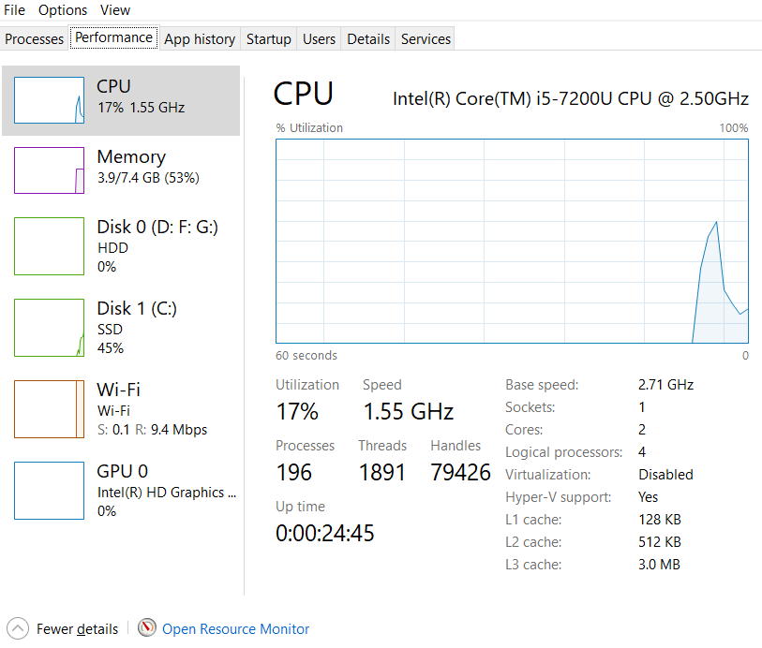

**MAC Address:**

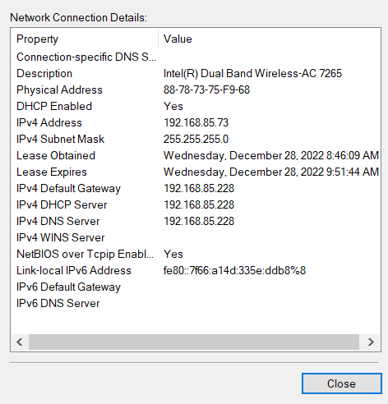

**GitHub profile link:**

<https://github.com/HuzaifaChughtai/IST>